Photo by [Branden Tate](https://unsplash.com/photos/XgEHOPn7h_E?utm_source=unsplash&utm_medium=referral&utm_content=creditCopyText) on [Unsplash](https://unsplash.com/search/photos/uneven?utm_source=unsplash&utm_medium=referral&utm_content=creditCopyText)



Photo by [Samuel Zeller](https://unsplash.com/photos/F8gM_qLa7mw?utm_source=unsplash&utm_medium=referral&utm_content=creditCopyText) on [Unsplash](https://unsplash.com/search/photos/snake?utm_source=unsplash&utm_medium=referral&utm_content=creditCopyText)

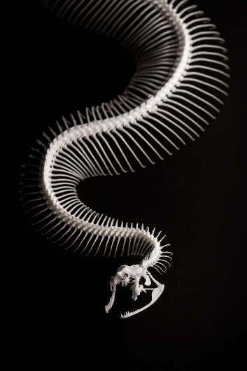

Photo by [Jong Marshes](https://unsplash.com/photos/zrFVG_8Xjh8?utm_source=unsplash&utm_medium=referral&utm_content=creditCopyText) on [Unsplash](https://unsplash.com/search/photos/snake?utm_source=unsplash&utm_medium=referral&utm_content=creditCopyText)

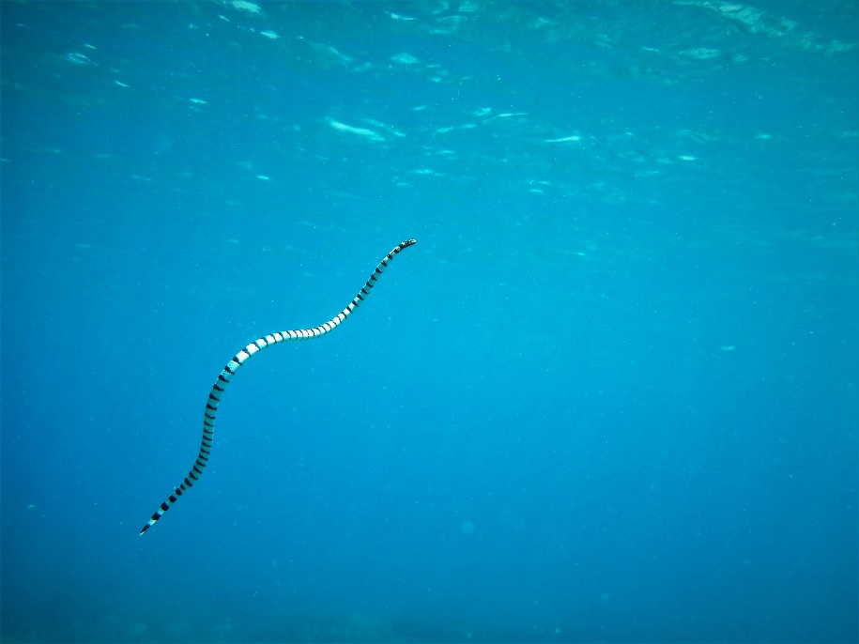

Photo by [Brandon Nelson](https://unsplash.com/photos/2smDZopBMso?utm_source=unsplash&utm_medium=referral&utm_content=creditCopyText) on [Unsplash](https://unsplash.com/search/photos/curve?utm_source=unsplash&utm_medium=referral&utm_content=creditCopyText)

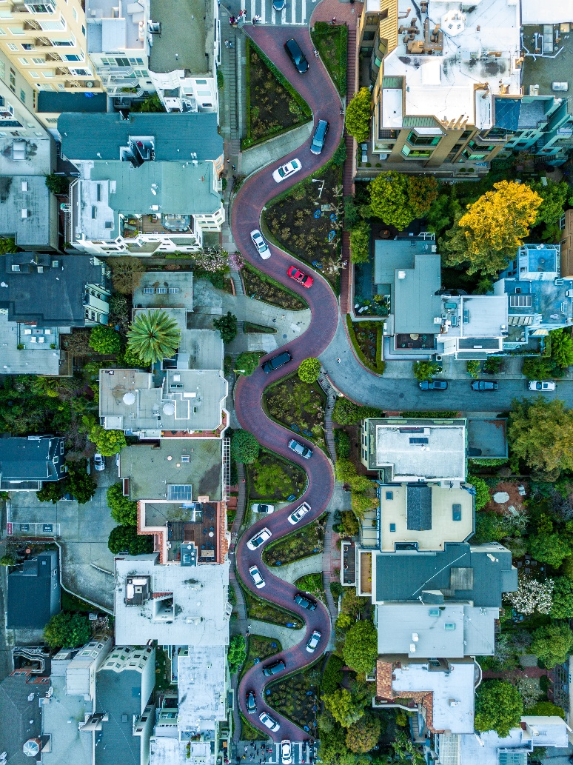

Photo by [Ludovic Fremondiere](https://unsplash.com/photos/3XN-BNRDUyY?utm_source=unsplash&utm_medium=referral&utm_content=creditCopyText) on [Unsplash](https://unsplash.com/search/photos/curve?utm_source=unsplash&utm_medium=referral&utm_content=creditCopyText)

